Allameh Bohlool Gonabadi Hospital

Cataract Surgery
Information booklet for patients

Department of Eye Surgery
Dr.Hamzeh Nasiri Surgeon And Ophthalmologis
Health Education Unit

What is a Cataract?
As we age, the lens begins to change and starts to block light from reaching the back of the eye.
This is a cataract, and over time it will grow and block more light. Finally, enough light rays are blocked from reaching the back of the eye that it becomes hard to see. A cataract is not a "film over the eye" but rather your natural lens once it has become clouded What Causes a Cataract?
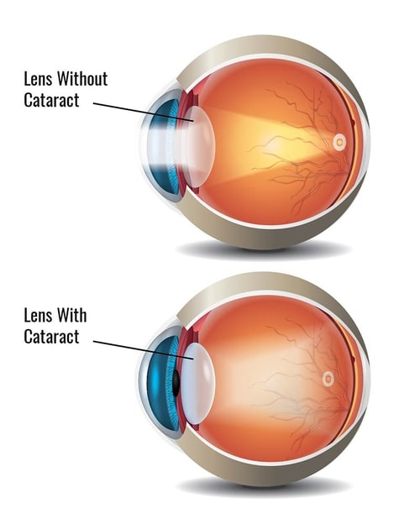

What Causes a Cataract?
Cataracts are a normal part of aging.
Eye injury, certain diseases (such as diabetes), and some medications (such as steroids) may also cause cataracts. However, in 95% of cases cataracts are simply caused by the aging process.

Cataract Surgery
Surgery is needed to remove the clouded lens, and replace it with a new, clear lens implant called an "intraocular lens" (IOL).
Cataracts are treated with an outpatient surgical procedure. Typically, this procedure lasts about 15-20 minutes. Although you are awake for the surgery, we will apply freezing drops and a mild sedative to ensure you are pain-free and relaxed throughout the procedure.

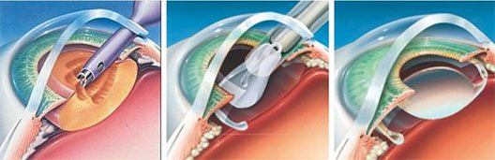
3)The IOL unfolds and is set to its permanent position.
2) The IOL is inserted through the same small incision.
1) A small probe (about the size of a pen tip) is inserted and used to break up and remove the cataract.

What is an Intraocular Lens (IOL)?
An intraocular lens (IOL) is the replacement lens that is surgically implanted into the eye to replace the natural clouded lens3 that is removed during cataract surgery. The IOL is necessary to focus light on the back of your eye and will stay in place for the rest of your life.
All IOLs are of high quality and will provide good, long-term, stable vision.

Preparation before cataract surgery

- You must be accompanied by another person to come to this center for surgery.
- Take a bath the night before surgery.
- If you have it, bring all your medical documents (examinations, photos, medical advice, brain, lung, etc.) with you.
- If you have a special disease such as high blood pressure or drug pre-treatment or special allergies, you must use the practice of the attending physician and anesthesiologist.
- Before leaving home, remove all your jewelry, ornaments, wristwatch, etc.
- Avoid makeup and nail polish.
- When going to the hospital, to facilitate the examination, take comfortable and loose cotton clothes with you.
- Bring your medications.
- He must fast for 6 hours before the operation.
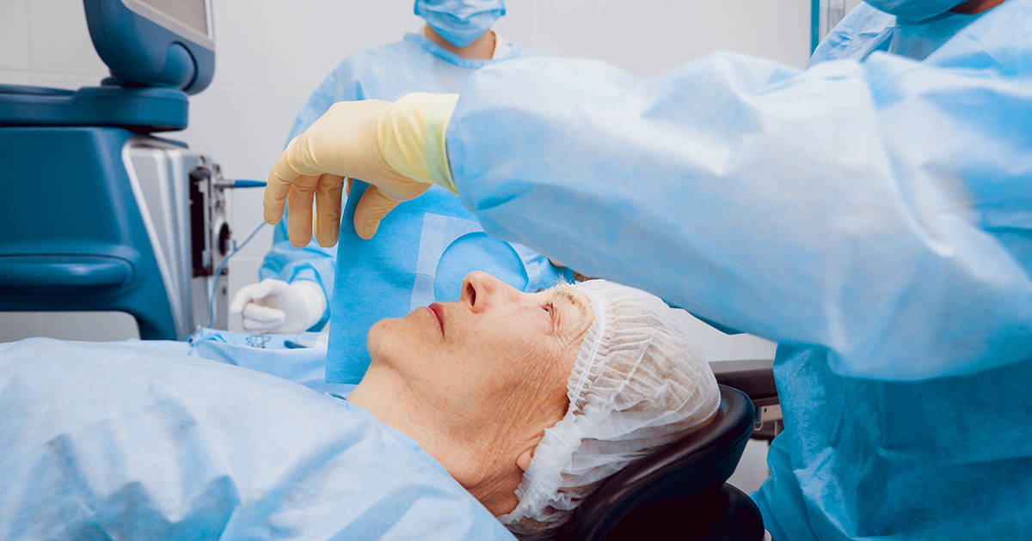

Guide after cataract surgery
After the operation, the doctor removes the eye bandage. Note that the vision of the operated eye may not be very clear immediately after removing the dressing.
Do not worry about this issue.
After removing the bandage, start using eye drops.
The following two drops are usually prescribed after the operation:
Name of the drop: | first week | second week | third  week | Fourth  week
Betamethasone (Betazonite) | Every 2 Hours | Every 4 Hours | Every 6 Hours | Every 8 Hours
Levofloxacin (Eftaquix) | Every 2 Hours | Every 4 Hours | Discontinue | Discontinue

The correct way to use eye drops
- Wash your hands properly (with soap or washing-up liquid).
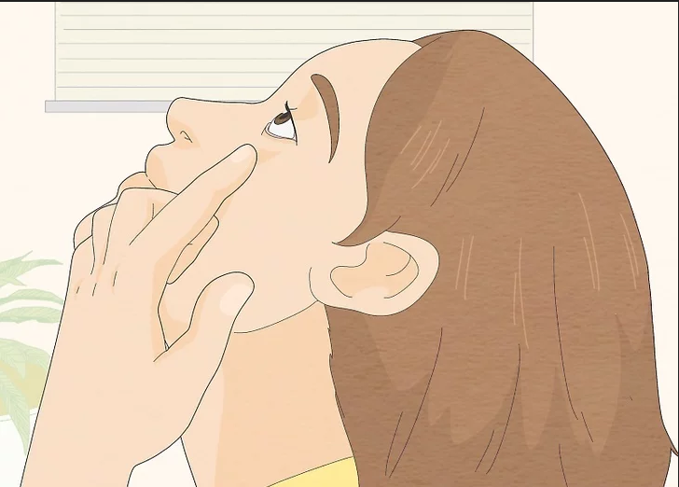
2. Tilt your head back a little.
3. Pull the lower eyelid down.

4. Put a drop in the hollow between the eye and the eyelid.
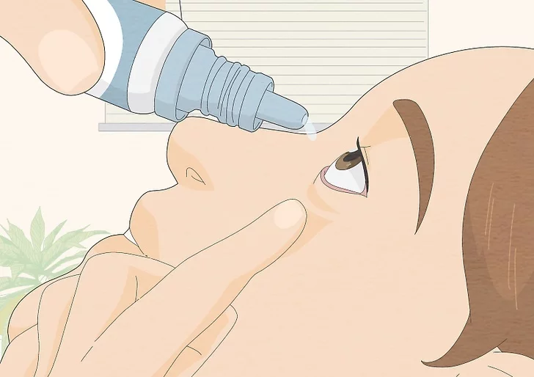
5. The dosage of each type of drop is always one drop. If you are not sure that the drop has entered the eye, pour another drop.
6. When instilling eye drops, the tip of the dropper should not touch the surface of the cornea, eyelashes or eyelid; Because it causes contamination of the drop.
7. After instilling the drop, close your eyes for 30 seconds. Avoid intense blinking.
8. If it is time to use two drops together, it is better to leave at least 3 to 5 minutes between the use of two drops.
9. It is better to have eye drops dripped into your eyes by another person.
10. If it is time to use the drops during sleep, you do not need to wake up to use the drops.

- Bring your medicines with you every time you go to the doctor.
- Also, consult your eye doctor about the use or non-use of eye medicines that you used before. If you need to continue it, use new drops, because opened drops may be contaminated and increase the risk of intraocular infection.

Care of the operated eye
Avoid scratching, rubbing, applying pressure to the operated eye and tightly squeezing the eyelids; Because it may cause the opening of the wound and displacement of the lens.
For this reason, an eye protector is placed on your eyes for a week.
This protector acts as a shield against possible impact.
Behind the shield, the eye must be open and you can even see through the holes of the shield.
You can put the protector on the operated eye with glue or tape.
It is better to use a protector while sleeping to prevent possible unconscious impacts while sleeping.
If you are in a crowded place such as the street, bus, etc., and also if you have a small child at home, be sure to use a protector.
The plastic protector is washable, so wash it daily with soap and water and dry it. Avoid putting gauze or cotton under the eye protection due to the increased possibility of infection.

Nutrition and diet
After waking up, the diet and taking the previous medicines will return to the normal routine, and there is no need to change the diet, and it is only better to use soft food meals in the first hours after the operation. At the same time, prevent constipation by eating the right amount of vegetables, fruits and water.

Bathing time and washing the face
- It is safe to take a shower 48 hours after the operation (of course, be careful not to rub the eyes).
- Getting water into the eye after surgery may cause germs to enter the eye and start an infection.
- For this reason, avoid getting water into the eye while washing your face or taking a bath.
- This possibility decreases after a few days.
- You can wash your face or take a bath after a few days of surgery.
- It is better to do this with your eyes closed so that water does not enter your eyes.
- It is better to use baby shampoo to wash the head in the first weeks after the operation.
- Do not let shampoo and soap get into the eyes.
- It is not forbidden to rub a wet hand on the face for ablution; avoid splashing water on the face and eyes as well as on the soil.
- Avoid going to swimming pool and sauna for a month.
- Avoid using cosmetics and contact lenses (cosmetic and medical) for 3-4 weeks. Because cosmetics contain irritants and can cause eye irritation and even eye infections, it is better not to use them in the first few weeks.

Activity rate
- Avoid intense physical work, intense exercise, lifting heavy objects, bending your head below waist level for a long time, prostration for 1 week.
- Usual office work, as well as reading and watching TV can be started from the very beginning. Although it may be a bit tiring due to the poor visibility at the beginning of the operation.
- Due to the incomplete vision in the first days after the surgery, avoid doing tasks that require accurate vision such as driving, piloting, working with precise and dangerous machinery (if your vision is not suitable). After returning the sight, it is possible to do these things.
- Lie on your back or side when sleeping; And preferably do not sleep on your stomach or towards the operated eye.
- Hot and cold air does not harm the operated eye.

Signs and symptoms of little importance after the operation
The presence of these symptoms is not a reason to see a doctor:
- Feeling dry and with a scratchy feeling or like a needle going into the eye. This symptom is caused by the wound of the surgical site and goes away with time.
- Brief secretion and sticking of eyelashes is normal.

Important symptoms after cataract surgery

Severe pain that is not relieved by oral medication
Progressive or sudden vision loss
Extreme sensitivity to light
Severe redness of the eye, severe and purulent discharge
Creating flies and sparks
If it occurs, see your doctor immediately; If you do not have access to your surgeon, go to the nearest ophthalmologist or eye emergency clinic.

Re-examination time
After cataract surgery, visit again for a check-up.
Post-operative examinations are recommended on the first day, first week, fourth week, third month and then once a year; Please note that according to your eye condition, the interval between examinations may be reduced.
Always ask your doctor about the time of re-examination.

Time to determine the glasses number
Usually, in the first few weeks after the operation, the number of the eye is changing and the score of the previous glasses is changed, and it is possible that your previous glasses are not suitable for you.
Mostly, within one to two months after the operation, the glasses score is fixed and near glasses (and distance glasses if needed) can be ordered.
Also, if you are sensitive to light, you can use sunglasses.

